

DAFFODIL INTERNATIONAL UNIVERSITY
DEPARTMENT OF COMPUTER SCIENCE AND ENGINEERING
FYDP (Phase-I) Evaluation Report
reporting period- summer 2026

Project Identification:
I. Project Title
II. Group Members | - Name: Arnob Das  Student ID: 0242310005101361  - Name: Md Shazzadur Rahman Piash  Student ID: 0242310005101583
III. Supervisor | Name: Mr. Saiful Islam  Designation: Assistant Professor
IV. Co-Supervisor | Name: Md Tanvirul Islam  Designation: Lecturer
V. Submission Date:
VI. Certificate: | “This is to certify that the final year design project work until Phase-I evaluation held on ___________________, titled as stated in Sec. I, executed by the students’ group mentioned in Sec. II, have been found satisfactory and every section of this report is reflecting the same.” | (Signature of Supervisor & date)

Project Insights
Thematic Area(s):  [Just click the check box] | Artificial Intelligence and Machine Learning | ☒
 | Deep Learning | ☒
 | Health Informatics | ☐
 | Cybersecurity | ☐
 | Software Engineering and Development | ☐
 | Blockchain Technology | ☐
 | Internet of Things (IoT) | ☐
 | Computer Networks | ☐
 | Computer Vision | ☐
 | Natural Language Processing (NLP) | ☐
 | Robotics | ☐
 | Game Development | ☐
 | Cloud Computing | ☐
 | Image Processing | ☐
 | Others (please specify):
Software packages, tools, and programming languages | [list down the software, programming languages, and packages you have used to do your project]

CO Description for FYDP-Phase-I
CO | CO Descriptions | PO
CO4 | Perform economic evaluation, cost estimation, and apply suitable project management procedures throughout the FYDP lifecycle in the context of developing the “ ” project. | PO11
CO6 | Select and apply appropriate methodologies, resources, and contemporary engineering/IT tools for prediction, modeling, and solving complex engineering processes for the “ ” project. | PO5
CO7 | Assess societal, health, safety, legal, and cultural issues and responsibilities in professional engineering practice related to the FYDP problem. | PO6
CO10 | Operate effectively as an individual and as a member/leader in multidisciplinary teams during FYDP. | PO9

- Project Overview

  - Introduction
This research addresses a critical flaw in current dropout prediction systems: they predict but do not explain. Universities receive at-risk lists without understanding whether problems stem from attendance, academics, or finances. Without explanations, interventions become guesswork. This project combines LSTM for temporal modeling with SHAP for interpretability, creating a transparent system that tracks evolving risk while explaining each prediction. Pre-admission data enables earlier identification, and threshold analysis reveals when intervention becomes critical.
  - Background Study
Summarize the relevant background information and literature that supports your project.

  - Gap Analysis
Summarize the gap you have observed from the background study
- Objectives
The objectives of Phase I are:
- To understand the structure and characteristics of the selected student dropout dataset through Exploratory Data Analysis (EDA).
- To identify the key demographic, academic, and financial features available in the dataset for dropout prediction.
- To analyze the distribution, quality, and relationships of the dataset features to support effective model development.
- To preprocess the dataset by preparing the features for machine learning, including encoding and train-test splitting.
- To develop and evaluate a baseline Random Forest classification model for predicting student dropout.
- To establish a performance benchmark that will be used for comparison with more advanced models in the later phases of the research.

- Methodology/ Requirement Specification:

  - Research Design/ Prototype Design
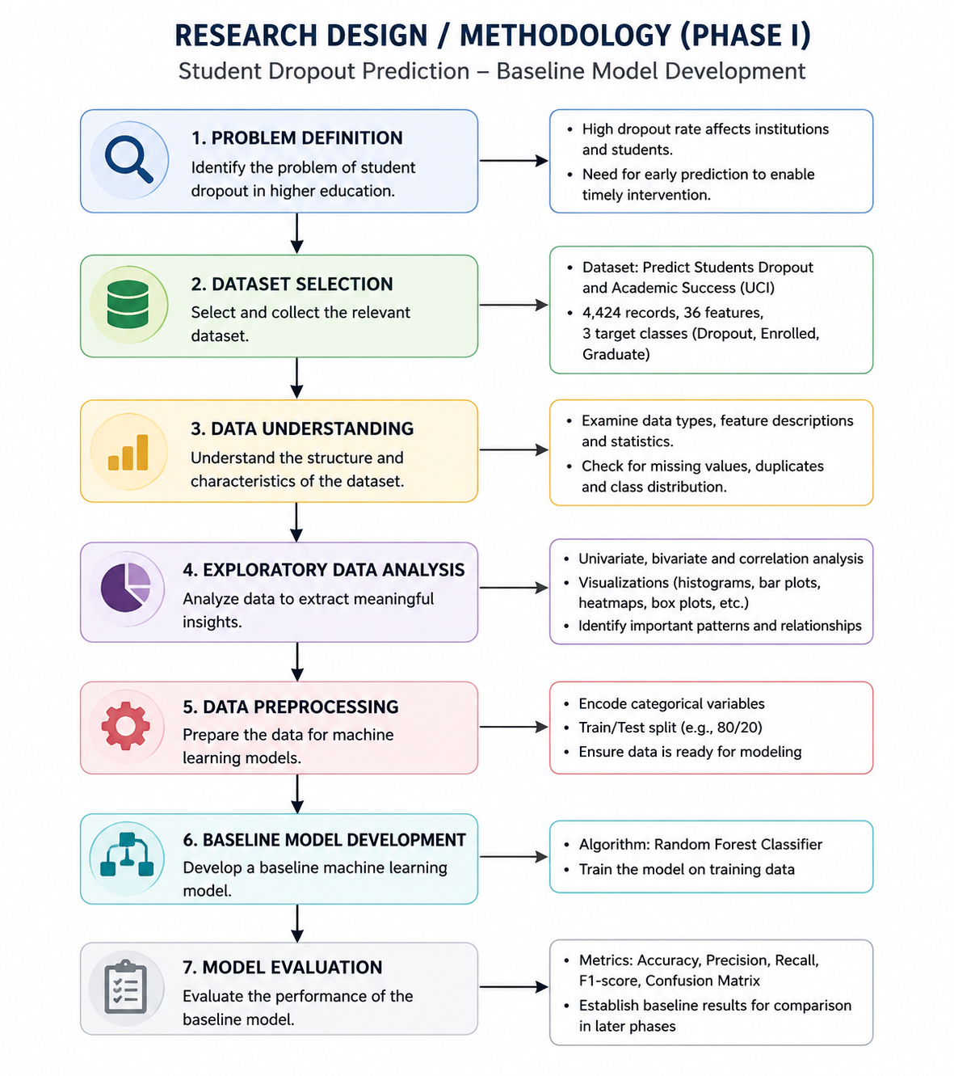
This research adopts a quantitative, data-driven methodology to develop a machine learning model for predicting university student dropout. The study utilizes the publicly available "Predict Students Dropout and Academic Success" dataset obtained from the UCI Machine Learning Repository.
The research process began with dataset selection and understanding, followed by Exploratory Data Analysis (EDA) to examine the dataset's characteristics, feature distributions, and class balance. Based on the EDA findings, the dataset was preprocessed by encoding categorical variables and splitting the data into training and testing sets.
A Random Forest classifier was then developed as the baseline machine learning model. The model was trained using the processed dataset and evaluated using standard classification metrics, including accuracy, precision, recall, F1-score, and confusion matrix. The results obtained in this phase establish a baseline performance for comparison with more advanced models that will be implemented in subsequent phases of the research.

  - Data Collection/ Need Assessment
The dataset used in this research was obtained from the UCI Machine Learning Repository. It is a publicly available and licensed dataset titled "Predict Students Dropout and Academic Success", created from a higher education institution by integrating data from several institutional databases. The dataset contains 4,424 student records with 36 input features and one target variable representing three classes: Dropout, Enrolled, and Graduate.
The collected data includes students' demographic information, academic background, socioeconomic status, financial information, and academic performance during the first and second semesters. Since the dataset was already preprocessed by its creators, it contains no missing values or significant anomalies, making it suitable for machine learning analysis.
The dataset was selected because it provides comprehensive information relevant to student dropout prediction and includes semester-wise academic performance, which aligns with the objectives of this research. Python was used as the primary tool for loading, inspecting, and processing the dataset during the Exploratory Data Analysis (EDA) and baseline model development phases.
  - Analysis Techniques
The analysis was conducted using Python and its data science libraries, including Pandas, NumPy, Matplotlib, Seaborn, and Scikit-learn. Initially, Exploratory Data Analysis (EDA) was performed to understand the dataset structure, identify feature types, examine class distribution, detect duplicate records, and analyze relationships among variables using descriptive statistics and visualization techniques.
After EDA, the dataset was preprocessed by encoding categorical variables and splitting the data into training and testing sets. A Random Forest classifier was then developed as the baseline machine learning model to predict student dropout. The model's performance was evaluated using standard classification metrics, including accuracy, precision, recall, F1-score, and confusion matrix. The results obtained in this phase will serve as the baseline for comparison with more advanced models in the subsequent phases of the research.

- Progress Achieved:

  - Completed Tasks
During this reporting period, the following tasks and milestones were successfully completed:
- Literature Review: Collected and reviewed relevant research papers on student dropout prediction, machine learning, and explainable artificial intelligence to understand existing approaches and identify research gaps.
- Research Planning: Finalized the research objectives, research questions, methodology, and selected the project title with supervisor approval.
- Dataset Selection: Selected the "Predict Students Dropout and Academic Success" dataset from the UCI Machine Learning Repository as the primary dataset for this research.
- Dataset Understanding: Studied the dataset structure, feature descriptions, and target classes. The dataset features were categorized into demographic, academic, financial, and socioeconomic factors.
- Exploratory Data Analysis (EDA): Performed exploratory data analysis to examine the dataset characteristics, feature distributions, class distribution, descriptive statistics, duplicate records, and correlations among variables.
- Data Preprocessing: Prepared the dataset for machine learning by encoding categorical variables and splitting the dataset into training and testing sets.
- Baseline Model Development: Developed and evaluated a Random Forest classifier as the baseline prediction model. The evaluation results obtained in this phase will serve as a benchmark for comparison with advanced models in subsequent phases.

  - Results Obtained
The initial phase of the project has been successfully completed. The student dropout dataset was collected, cleaned, and analyzed through Exploratory Data Analysis (EDA). The dataset contains 4,424 student records with 36 input features and one target variable representing three student outcomes: Dropout, Enrolled, and Graduate. No missing values or duplicate records were found, indicating that the dataset is suitable for machine learning.
Several visualizations, including class distribution, correlation heatmap, histograms, and box plots, were generated to understand the characteristics of the data. The analysis showed that the dataset has a moderate class imbalance, with Graduate being the largest class and Enrolled the smallest. The visualizations also indicated that semester academic performance features exhibit noticeable differences across the target classes.
A baseline Random Forest classification model was trained using all available input features. The model achieved an accuracy of 76.72% on the test dataset. Feature importance analysis revealed that Curricular Units (2nd Semester Approved), Curricular Units (2nd Semester Grade), Curricular Units (1st Semester Approved), Curricular Units (1st Semester Grade), Admission Grade, and Age at Enrollment were among the most influential features for predicting student outcomes.
These preliminary results demonstrate that the dataset is appropriate for the student dropout prediction task and provide a strong foundation for the next phase, which will involve feature selection, model comparison, and performance optimization.

- Challenges Faced:
SI No. | Issues and Challenges | Strategies or Plans
1 | Selecting an appropriate student dropout dataset with sufficient features for machine learning. | Reviewed multiple publicly available datasets and selected a well-structured dataset suitable for the research objectives.
2 | Understanding the dataset attributes and relationships between features. | Conducted Exploratory Data Analysis (EDA) using statistical summaries and visualizations to gain insights into the data.
3 | Setting up the Python environment and installing the required libraries for data analysis and model development. | Configured the development environment, installed the necessary packages, and verified the setup before proceeding.
4 | Identifying the most relevant features for predicting student dropout. | Trained a baseline Random Forest model and used feature importance analysis to identify influential features. Further feature selection will be performed in the next phase.
5 | Selecting an appropriate baseline machine learning model for initial evaluation. | Implemented a Random Forest classifier to establish baseline performance. Additional machine learning models will be compared in the next phase to identify the best-performing model.

- Next Steps:
Outline the tasks and milestones planned for the next phase of the project.
SI No. | Next Task | Estimated Completion Time (MM-YY)
1 | Perform feature selection and identify the most relevant features for student dropout prediction. | 08-26
2 | Train and compare multiple machine learning models (e.g., Logistic Regression, Decision Tree, SVM, Random Forest, XGBoost, The proposed LSTM). | 09-26
3 | Apply Explainable AI (XAI) techniques, such as SHAP (SHapley Additive exPlanations), to interpret model predictions and identify the most influential features and optimize the best-performing model using hyperparameter tuning and cross-validation. | 10-26
4 | Evaluate the final model using performance metrics such as Accuracy, Precision, Recall, F1-Score, ROC Curve, and Confusion Matrix. | 10-26
5 | Analyze the final results, prepare visualizations, complete documentation, and finalize the project report. | 11-26

- Updated Timeline:
Provide an updated timeline, highlighting progress made and indicating any adjustments.
Tasks | Weeks
 | 6 | 7 | 8 | 9 | 10 | 11 | 12 | 13 | 14 | 15 | 16 | 17 | 18 | 19 | 20 | 21 | 22 | 23
Dataset collection and selection + feature analysis
Background study + Gap analysis
EDA analysis
Baseline Model Training(Random Forest)

Estimated Work Period
Actual Work Period

- Resources Utilized:
Following resources were utilized during the reporting period :
SI No. | Resource Type | Resources Utilized
1 | Programming Language | Python 3.11
2 | Development Environment | Visual Studio Code (VS Code) with Jupyter Notebook
3 | Libraries | Pandas, NumPy, Matplotlib, Seaborn, Scikit-learn
4 | Dataset | Student Dropout and Academic Success Dataset
5 | Version Control | Git and GitHub
6 | Documentation | Research papers and related literature on student dropout prediction and Explainable AI (XAI)
7 | Hardware | Personal laptop (Windows 11)

- Project Management and Financial Analysis:
Project Management: The project is being managed using a phased development approach. Phase 1 focused on literature review, dataset collection, exploratory data analysis (EDA), and developing a baseline machine learning model. Future phases will include feature selection, model comparison, explainability (SHAP), evaluation, and documentation. Progress is monitored through regular meetings with the project supervisor.
Estimated Cost: The project requires minimal financial expenditure as it utilizes open-source software and publicly available datasets. The estimated cost is limited to electricity and internet usage during development. Existing personal computing resources are used, so no additional hardware or software purchases are required.

- Future Considerations:
The following factors may impact the next phase of the project and will require careful consideration:
- Model Selection: Choosing the most suitable machine learning model to achieve high prediction accuracy.
- Feature Selection: Identifying the most relevant features while removing less significant ones without affecting model performance.
- Model Optimization: Applying hyperparameter tuning and cross-validation to improve the performance and generalization of the selected model.
- Explainable AI (SHAP): Implementing SHAP to interpret the model's predictions and identify the most influential features affecting student dropout.
- Model Evaluation: Comparing multiple machine learning models using performance metrics such as Accuracy, Precision, Recall, and F1-Score to select the best-performing model.
- Final Documentation: Completing the implementation, analyzing the results, and preparing the final project report and presentation.

- Conclusion:
This progress report summarizes the work completed during the first phase of the Student Dropout Prediction project. The literature review, dataset collection, and Exploratory Data Analysis (EDA) were successfully completed, providing a clear understanding of the dataset and its characteristics. A baseline Random Forest model was developed, achieving an accuracy of 76.72%, and feature importance analysis identified the most influential variables for prediction. The completed work provides a solid foundation for the next phase, which will focus on feature selection, model comparison, Explainable AI (SHAP), model optimization, and final evaluation to develop an accurate and interpretable student dropout prediction system.

References
[List your references here using IEEE format]
[1]
[2]
Appendix:
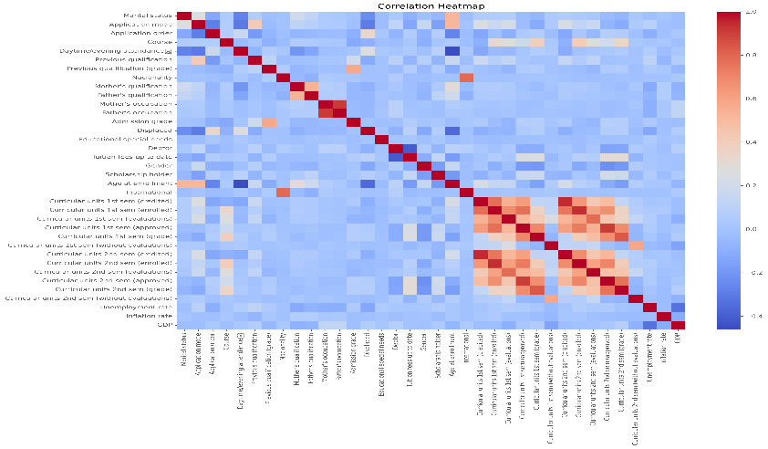
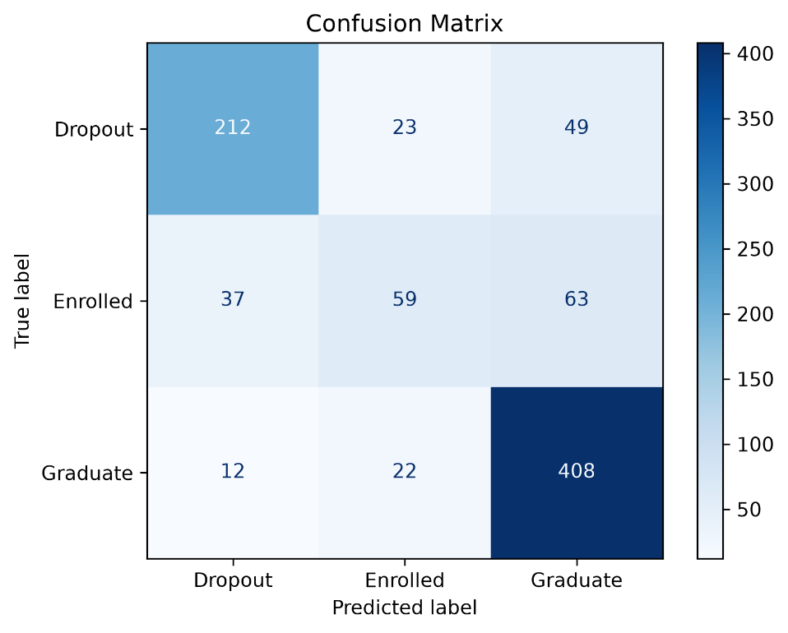
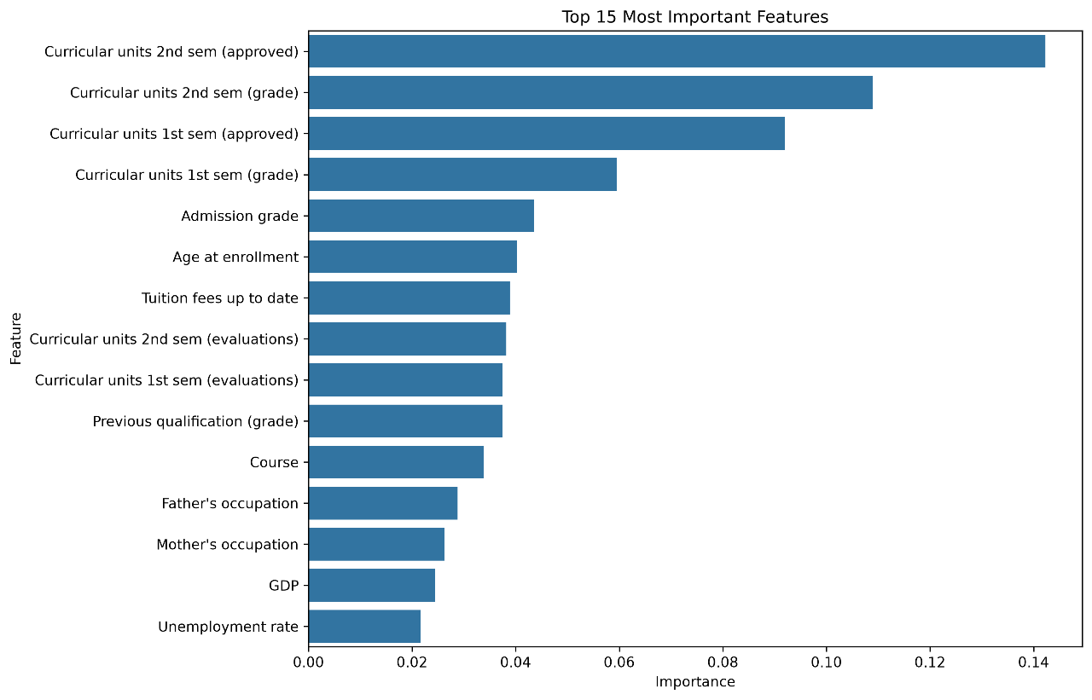
GitHub Repository Link: https://github.com/code-silence/student-dropout-prediction-research

FINAL YEAR DESIGN PROJECT
PHASE-I PROGRESS REPORT

This report, in the form of a template, has been specifically designed for BSc. students working on their Final Year Design Project (FYDP) at Computer Science and Engineering Department, Daffodil International University (DIU).

Every group of students is required to do the following:
- Complete all the sections of this template
- Get it certified by the assigned supervisor before one week of Phase-I evaluation presentations
- Submit 01 photocopy to each of the following, on or before the day of Phase-I presentations:
  - Supervisor
  - Internal Evaluator
- Submit original copy to FYDP committee on the day of Phase-I presentations.

Note:
- Use English
- There should be NO grammatical or spelling mistakes
- Submission after due date will not be accepted
- For more information, contact your Supervisor

Template prepared by:  FYDP Committee  Dept. of CSE, DIU | Template approved by:  Dr. Sheak Rashed Haider Noori  Professor and Head, Dept. of CSE, DIU

The students and faculty members of Computer Science and Engineering Department, Daffodil International University have full access rights to read and print this document without any prior notice to the Head and FYDP committee.

All rights are reserved.

